**DO NOT PRINT THIS PAGE**

**Steps to recreate diagram in yuml.me:**

**[User]-(Manage Wall)**

**(Manage Wall)>(Add Item)**

**(Manage Wall)>(Comment Item)**

**(Manage Wall)>(Like Item)**

**(Manage Wall)>(Share Item)**

**(Manage Wall)>(Ignore User)**

**(Manage Wall)>(Ignore Item)**

**[User]-(Login)**

**[User]-(Logout)**

**[User]-(Manage Groups)**

**(Manage Groups)>(Create Group)**

**(Manage Groups)>(Join Group)**

**(Manage Groups)>(View Group)**

**[User]-(Search)**

**[User]-(Change Profile)**

**[User]-(Set Info Permission)**

**[User]-(Manage Friends)**

**(Manage Friends)>(List Friends)**

**(Manage Friends)>(Add Friend)**

**(Manage Friends)>(View Friend)**

**(View Friend)<(View User)**

**[User]-(Manage Messages)**

**(Manage Messages)>(List Messages)**

**(Manage Messages)>(View Message)**

**(Manage Messages)>(Send Message)**

**[System]-(Send Notification)**

**SimpleFacebook: Project Definition**

Yet another social website where users can see and manage their social network. The application offers the possibility to manage the user list of friends, which are only considered as such after both parties confirm the existence of the relationship. Users can search for other users and browse the user profile (each user can configure the permissions details about what is seen in the profile). The search is made considering that users usually search for people in the nearby social graph.

Each user has also a Wall where items are shown. These items can be of various types (text, video, image, sound) and are published by friends. User can see the public Wall ordered by time (called the timeline) or the user own Wall (only items published by itself, or about him by others). Items can be considered 'liked' by users, commented and shared (published in its own timeline).

There's also a concept called "group" that users can create when they want to and name it like they want. A group doesn't have some info like the user (age, location, etc) but does have friends and a wall where everyone can post content.

The Wall has some filtering capabilities like ignoring a particular user, a group or even a particular item.

There a notification system that sends the user an email every-time new content related to him shows up.

Users can also send asynchronous messages to each other (ignoring the fact that they might not be friends).

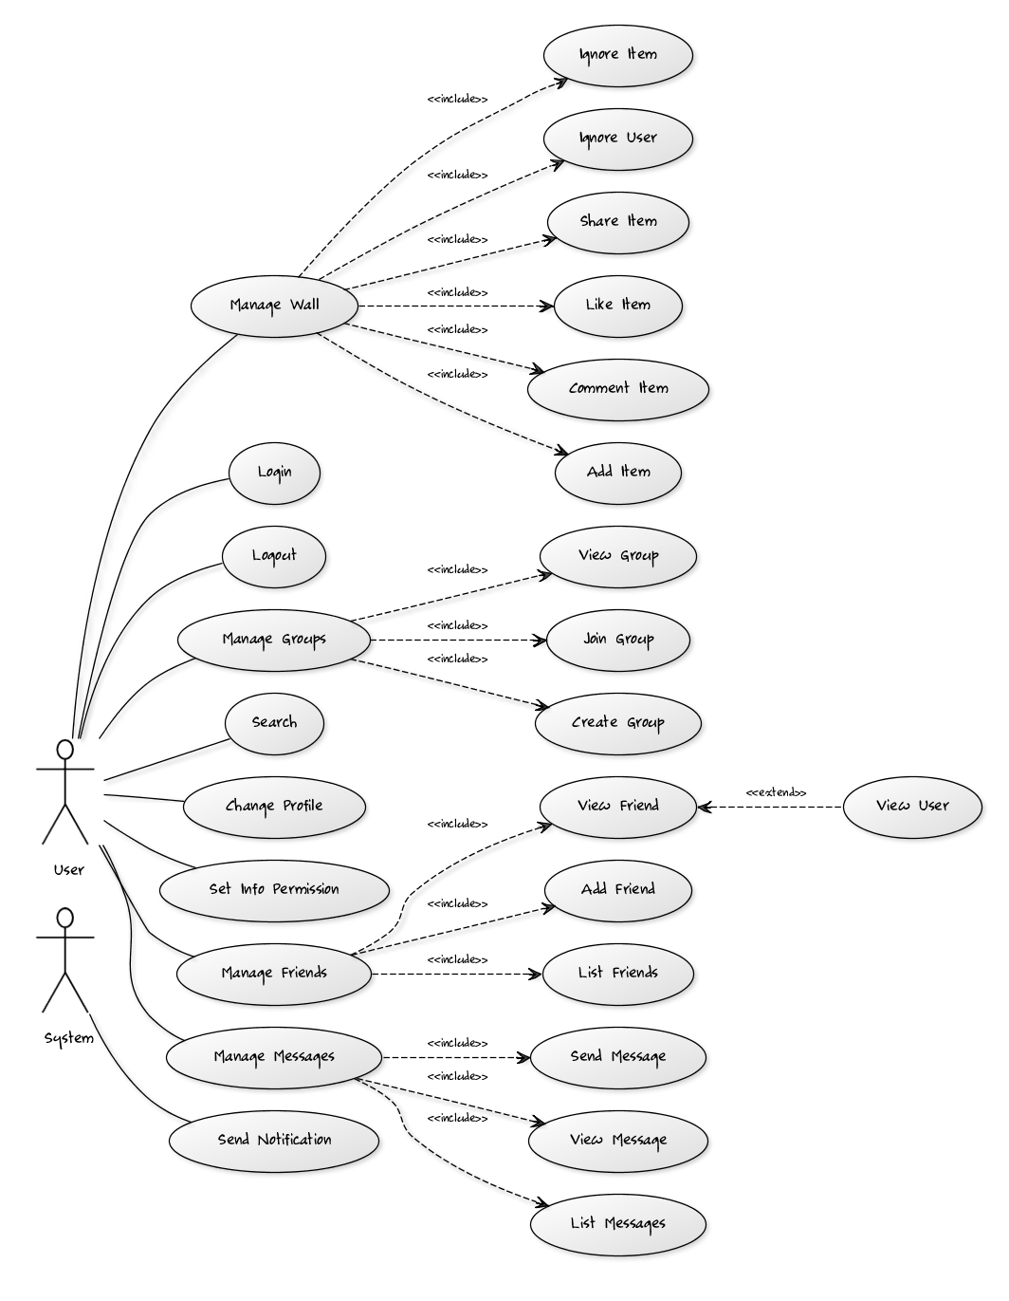**Use Case Model**

**Class Diagram**

